Personal Best Challenge

Head Shoulders Knees and Toes Challenge
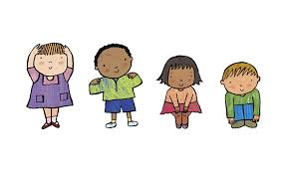
- Throw a ball in to the air above your head (if you don’t have a ball find something soft and small you can catch)
- Before you catch the ball, perform a part of the Heads, shoulders, knees and toes song
- Catch the ball and complete the song
Change the difficulty
Try to do multiple parts of the song in between catches to increase the difficulty (throw, head, shoulders and catch). How many parts can you do?
You can make it even harder by adding a clap to before each section of the song.

