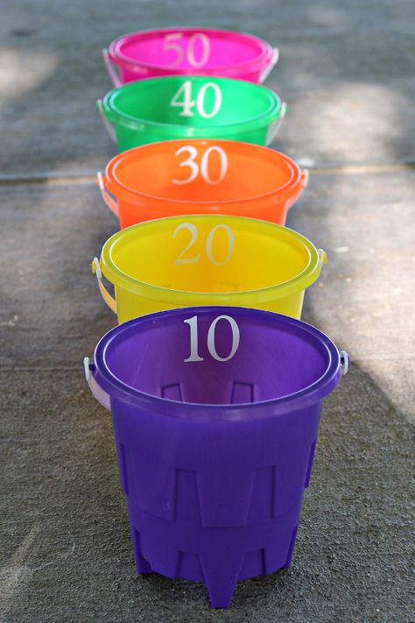
Personal Best Challenge

- Place your targets/target in a safe space and choose your starting point
- Throw the object (ball, balled up pair of socks or a scrunched piece of used paper)
- Aim for the targets, and see how many points you can get!
- See how many point you can get in 3 minutes

Change the difficulty
To make it harder, compete with someone from your home and see who can get the most points.
Move the target/targets further away every time you get a point.
How man different ways can get it in to the bucket?

To make it easier, move the targets closer.

