Skylark Class

West Kirby Primary School

Wirral

CH485EQ

27.11.20

Dear Sir David

Every week in our class we learn about a story that has been in the news. A few weeks ago the news story was about children at Fourlanesend Community Primary School in Cornwall, who had written a letter to you asking for help to get their message across to Comic Relief to stop making the red noses out of plastic. The campaign was successful and Comic Relief have now said the next red noses that come out in March will be made out of a more natural product called bagasse. We thought this was a great idea and showed what children can do to make a difference.

We went on to look at the problem of single use plastics in our environment and all the harm it can do. Following this lesson, a few of the children in the class were so concerned that they went home and wrote notes and created posters which they wanted to send to you. The children are aged either 4 or 5 and are just beginning to learn to write independently.

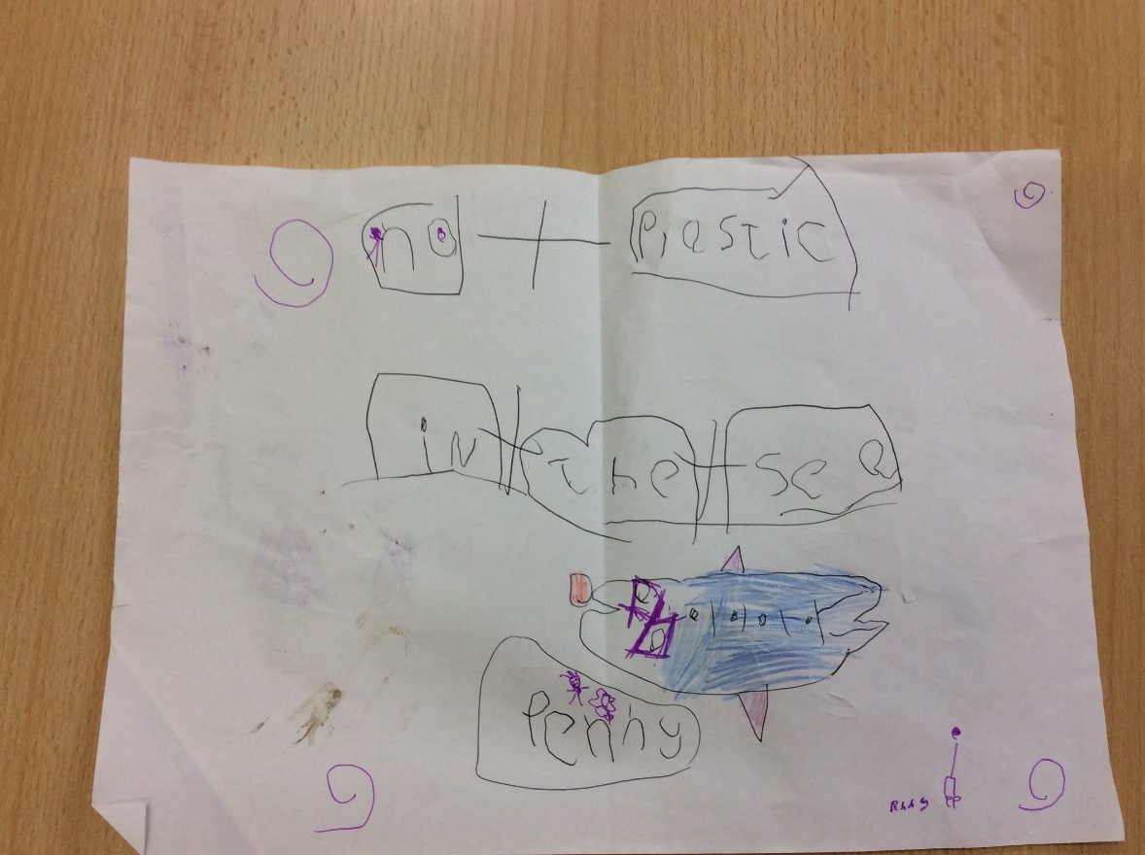

No plastic in the sea.

Penny aged 5

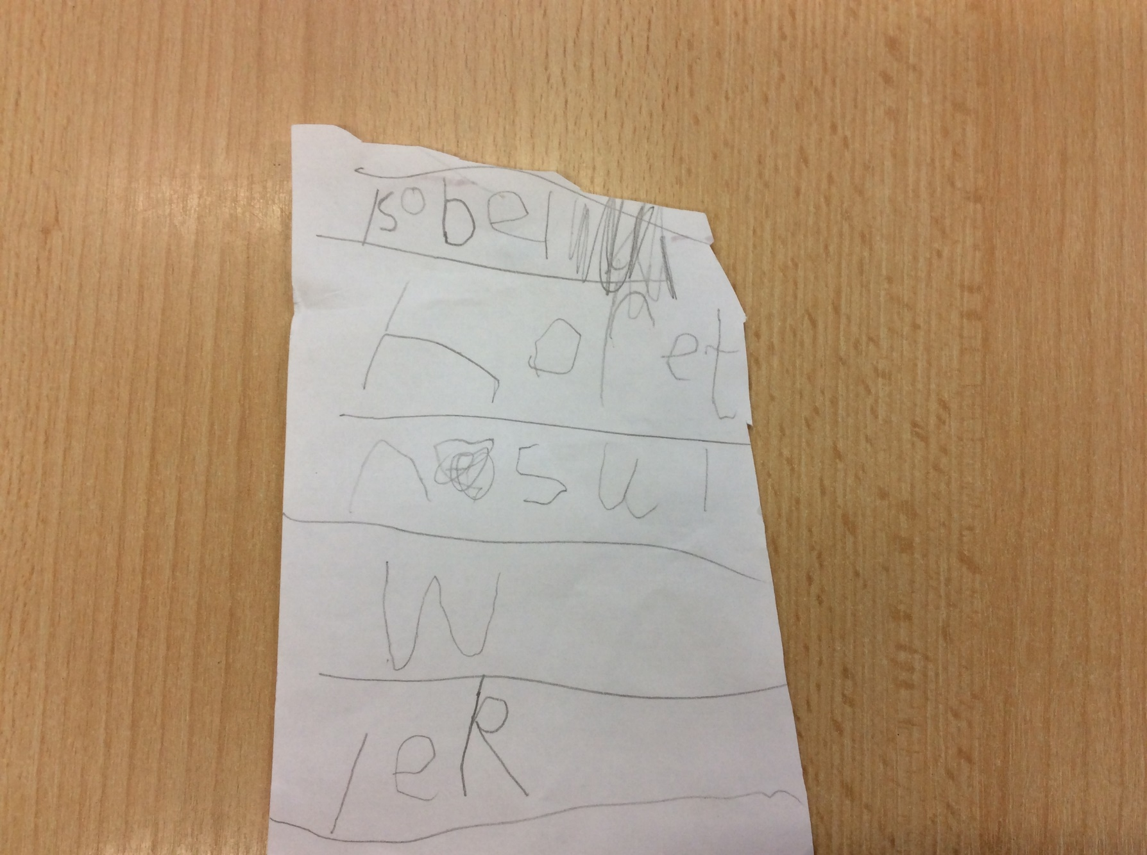Put no plastic in the water.

Red noses

Lucy aged 5

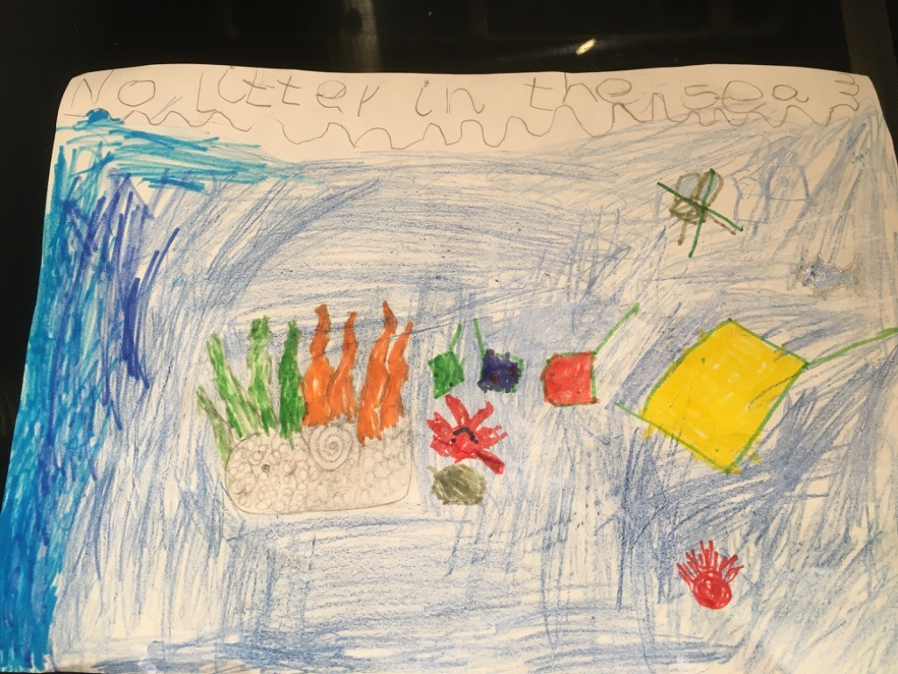

No litter in the sea.

Benjy aged 4

We hope that you like our pictures and posters.

With best wishes

From Mrs Smith, Miss Turnbull and all the children in Skylark Class.