Teddy Bear Run

How to play…

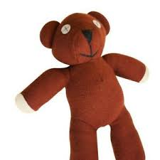

Place 3-5 stuffed animals in a line with a big space (enough to jump in) in between.

Jump between each bear, without jumping on them!

Can you try different jumps? Frog Jumps, hopscotch, hopping and leaps.

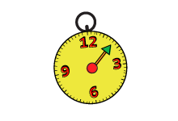
- Keep going for 10 minutes!

