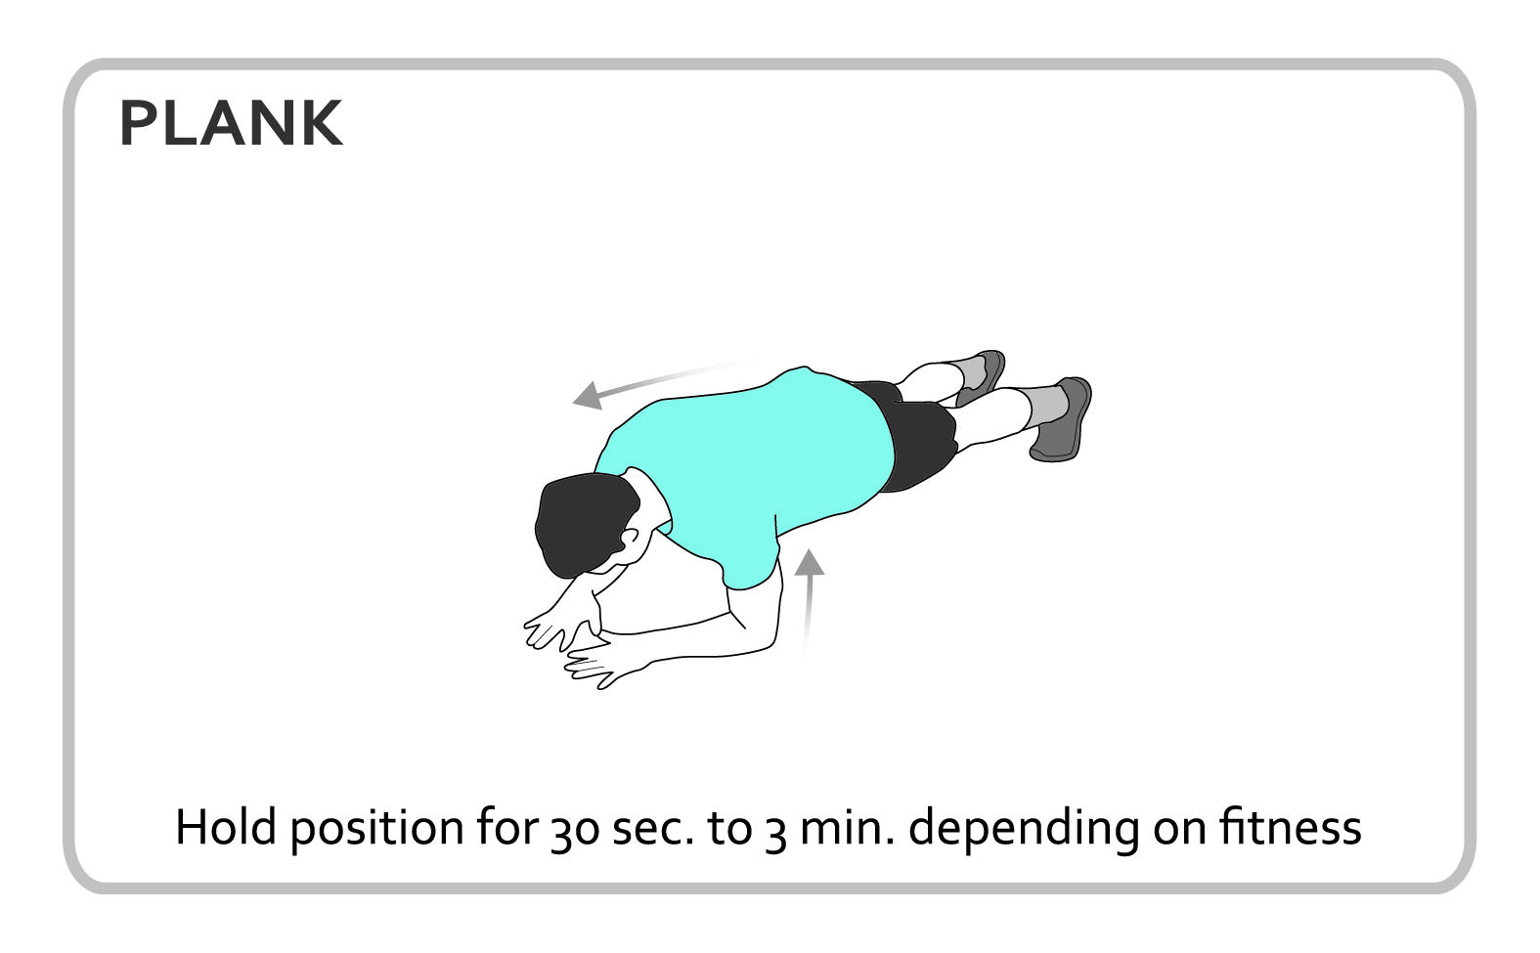
Personal Best Challenge

- Place forearms on the floor with elbows aligned with your shoulders
- Arms should be paralleled with the rest of your body
- Hold a plank position for 30sec-3min depending on fitness
- Time yourself each day and record you personal best

Change the difficulty
To make it harder, compete with someone from your home and see who can hold a plank the longest.

To make it easier, place knees on the floor while you plank.

