YEAR 6 UKS2 Foundation Subject Tasks – Sum 2 7Wk – w.c. 13.7.20
Science – How do our eyes work?
What do you already know about the eye?
Your eye works in a similar way to a camera: light passes through the lens of your eye and is 'recorded' on the back of your eye (the retina). Your eye sends the picture to your brain, and your brain turns the picture the right way up and tells you what you are looking at, so you see things the right way up.

If you can, watch these videos to find out more.
https://www.youtube.com/watch?v=8vN1UfMn2GA
https://www.youtube.com/watch?v=gvozcv8pS3c

Draw a diagram of the eye labelling the different parts.
Explain how your eye works to an adult.
Look after those eye of yours, you have exciting times in front of you year 6.
Active time -This is PE

Choose a daily activity from the online menu or choose one from our PE Activities folder.

https://www.youtube.com/playlist?list=PLYGRaluWWTojV3An2WEgsQ4qGFy_91jDL

Computing – Online safety activity 3
Computer access needed
https://www.thinkuknow.co.uk/globalassets/thinkuknow/documents/thinkuknow/parents/pdf/thinkuknow-8-10s-home-activity-sheet-3.pdf

Art/DT – Use collage to create a Henri Matisse picture.

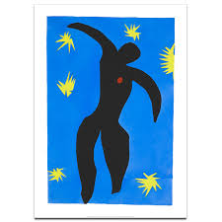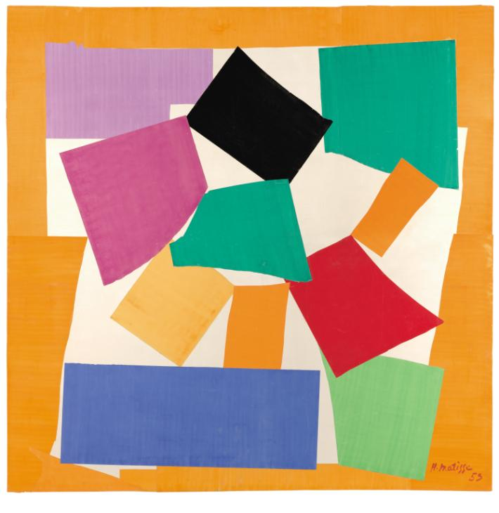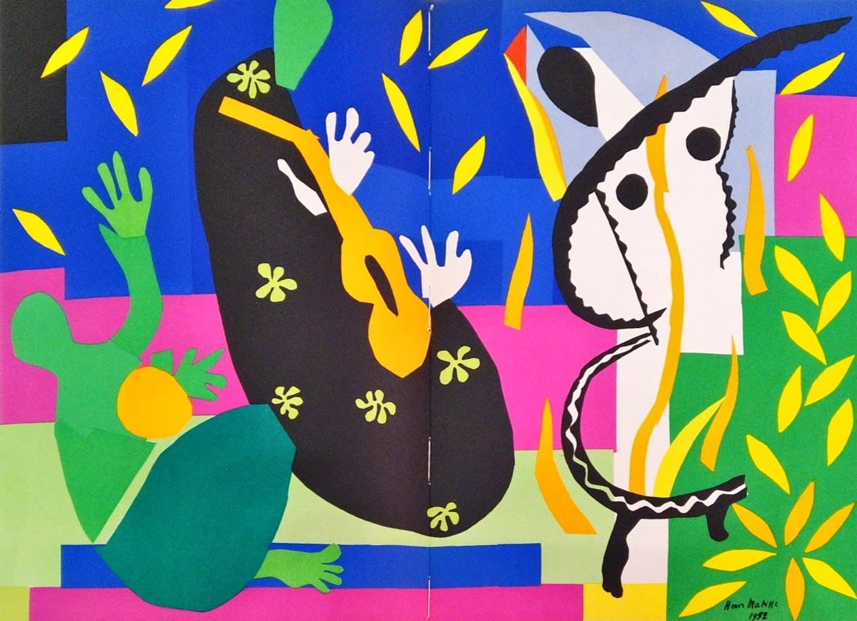
If you can, click on this link to follow the lesson.

https://classroom.thenational.academy/lessons/henri-matisse-and-collage-800310/activities/1

R.E / PHSCE. – What are your highlights in lockdown?
This was not how any of us expected your year 6 to be! But there have been many highlights as well as disappointments along the way.
Spend some time making a list of each. Discuss them with a friend or adult.
If you can, watch this video clip.
https://www.bbc.co.uk/newsround/news/watch_newsround

Year 6 Activity - Here are the songs chosen by some of you to sum up your time at WKPS. Enjoy listening to them.
Take That Shine
https://www.youtube.com/watch?v=JwC1Ctrj6Xk&app=desktop
Gerry & The Pacemakers - You'll Never Walk Alone
https://www.youtube.com/watch?v=OV5_LQArLa0&app=desktop
Kool & The Gang - Celebration
https://www.youtube.com/watch?v=3GwjfUFyY6M&app=desktop
Bruno Mars - Count on me
https://www.youtube.com/watch?v=Yc6T9iY9SOU&app=desktop
Queen - Don't Stop Me Now
https://www.youtube.com/watch?v=HgzGwKwLmgM&app=desktop
Tyrone Wells - Time of our lives
https://www.youtube.com/watch?v=VFPhEn6ifV0&app=desktop
Pharrell Williams - Happy
https://www.youtube.com/watch?v=y6Sxv-sUYtM

Geography / History - Getting to your new school

Draw a map of your route to school. Where will you need to cross the road? What time will you need to set off? If you are going by bus what time will you need to catch the bus? If you are getting a lift what time will you have to leave your house? How long is the journey? What time does school start? What time does school finish?

