Personal Best Challenge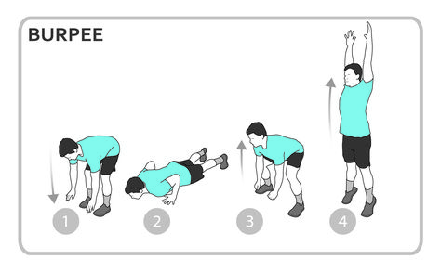
- Stand with your feet hip-width apart and your arms hanging loosely by your sides.
- Drive your hips back (like you are about to sit on a chair), bend your knees, and lower your body into a (nearly) full squat.
- Plant your hands on the floor, right in front of your feet and shift your weight onto your hands.
- Hop your feet back to softly land on the balls of your feet in a plank position.
- Do one push-up.
- Hop your feet back up to your hands and shift your weight onto your feet.
- Stand up while reaching your arms over your head and then jump up into the air.
- Land softly and immediately start the movement again from the beginning.

Change the difficulty
To make it harder, compete with someone from your home and see who can do the most burpees.
See how many you can do in 3 minutes, it is important to set yourself targets.
Record your score each week.

