Mighty Roar Jumps

How to play...

1
Run on the spot, then do a press-up.
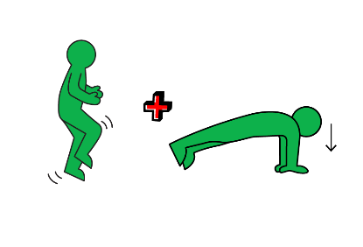
2
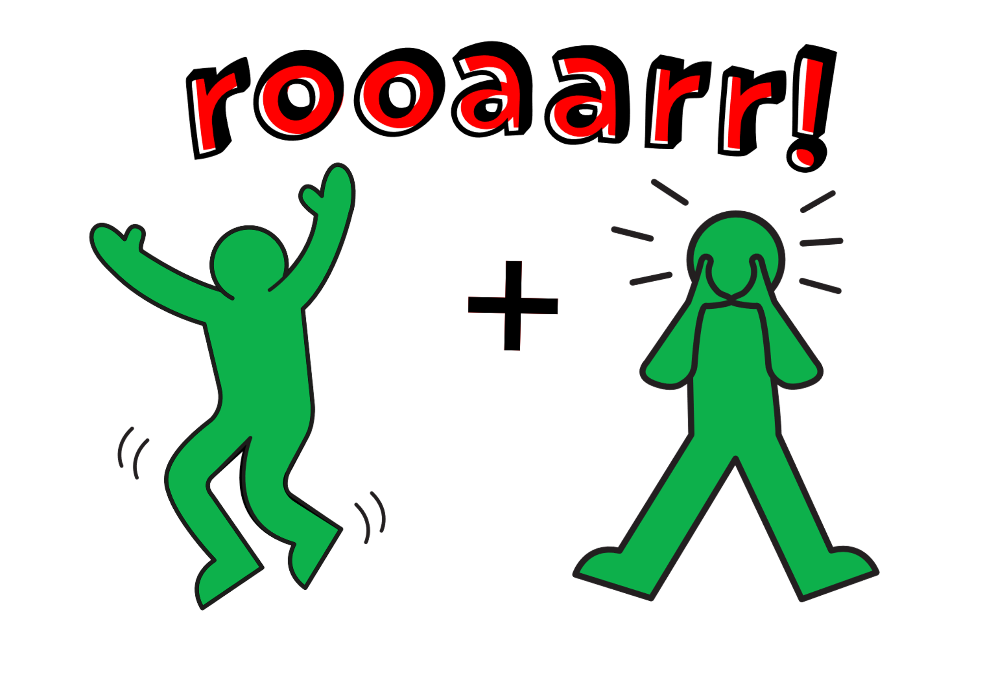
Next, jump up, roar and repeat! You can add in other animal noises for fun.
3
See if your grown up or someone at home can follow you moves.
4
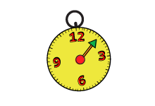
How long can you keep going? Can you do 10 minutes?

