Lion Races

How to play...

1. Grab a stopwatch and create a track with a start line and a finish line

2. Take it in turns to run around the track on all fours while your friend times you. Do not forget to make the noise of your favourite animal as you go!
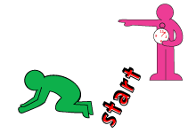

3. Do 10 laps if you're inside and 5 if you're outside.

4. See which of you is fastest.
