Follow the leader

How to play…

Choose one person to be the leader. Everyone else gets into a line behind them.
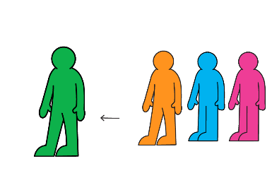

The leader sets off walking. Every few steps, they shapeshift into a move that everyone in the line has to copy, like a star jump, running on the spot or a dance move. Try to come up with as many different ones as you can! 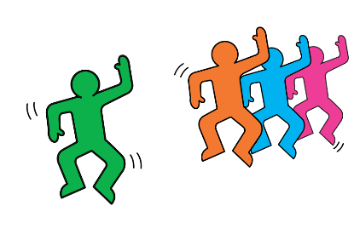

After 10 shapeshifts, the leader goes to the back of the line and the new leader starts shapeshifting.
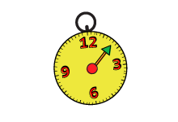
- Keep going for 10 minutes!

